GCP Event-Driven Data Ingestion Architecture

1. Overview
This document describes a production-grade, event-driven data ingestion architecture built on Google Cloud Platform (GCP).
The solution enables:
- Automatic processing of customer-uploaded data
- Reliable synchronization with a database
- Robust retry and failure handling mechanisms
- Full observability using logging and monitoring
This architecture is scalable, fault-tolerant, and suitable for enterprise deployments.

2. Architecture Components
- The system is composed of the following GCP services:
- Google Cloud Storage (GCS)
Stores incoming customer files (CSV, JSON, Parquet)
- Eventarc
Captures file upload events and routes them
- Pub/Sub
Acts as a buffer layer and enables retry mechanism
- Cloud Run
Executes scalable data processing jobs
- Cloud SQL
Stores processed data
- Cloud Logging & Cloud Monitoring
Provide observability, logs, and alerts

3. Architecture Diagram
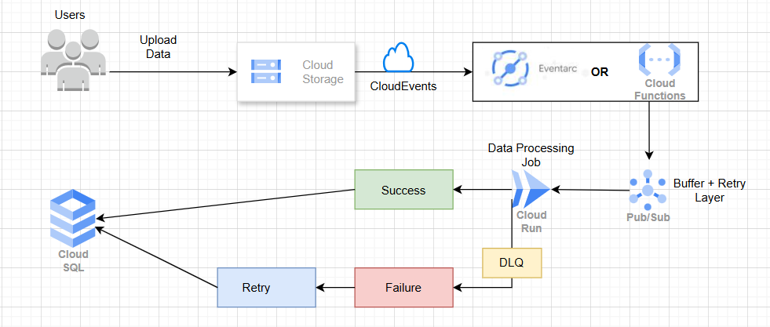

4. End-to-End Workflow
Step 1: Data Upload
- Customer uploads file into GCS bucket (/raw/ folder)
Step 2: Event Trigger
- GCS emits an object finalize event
- Event is captured by Eventarc
Step 3: Message Publishing
- Event is sent to Pub/Sub topic
- Ensures decoupling and reliability
Step 4: Data Processing
- Cloud Run service consumes message
- Performs:
  - File read from GCS
  - Schema validation
  - Data transformation
  - Deduplication
Step 5: Data Storage
- Processed data is written into:
  - Cloud SQL (transactional)

Step 6: File Handling
- Success → Move to /processed/
- Failure → Move to /failed/

5. Retry Mechanism (Critical Design)
5.1 Automatic Retry
- Pub/Sub automatically retries message delivery
- Triggered when:
  - Cloud Run returns error (non-2xx)
5.2 Retry Configuration
- Exponential backoff supported
- Configurable:
  - Retry interval
  - Maximum delivery attempts

5.3 Dead Letter Queue (DLQ)
- After max retries exceeded:
  - Message moves to DLQ
- Prevents infinite retry loops
- Stores failed events for analysis

5.4 Reprocessing Strategy
- Manual retry:
  - Operator replays failed messages
- Automated retry:
  - Scheduled job reprocesses DLQ

6. Idempotency Strategy (Important)
To ensure safe retries:
- Use unique identifiers:
file_name + record_id
- Perform UPSERT instead of INSERT
- Maintain processed file registry
This ensures:
- No duplicate data
- Safe reprocessing

7. Job Status Tracking
Maintain a tracking table:
job_id | file_name | status | start_time | end_time | error_message
Status Values:
- STARTED
- SUCCESS
- FAILED

8. Monitoring and Alerting
Using Cloud Monitoring:
Alerts to Configure:
- Job failure rate exceeds threshold
- No files processed within expected time
- DLQ message count > 0
Logging:
- Use structured logs in Cloud Logging
- Capture:
  - File name
  - Processing time
  - Errors

9. Best Practices
- Use structured folder design:
  - /raw/
  - /processed/
  - /failed/
- Implement:
  - Idempotent processing
  - Schema validation
  - File checksum validation
- Security:
  - Use IAM least privilege access
  - Restrict service account permissions
- Performance:
  - Optimize Cloud Run CPU/memory
  - Use parallel processing for large files

